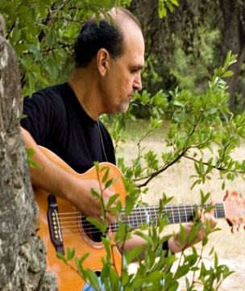
Eddie Cavazos is a songwriter, arranger, music educator and music minister. In his long career of teaching elementary music, he has written musicals, choral music, songs to accompany children’s books by award winning authors, songs for the dedication of new schools in the district, and folk song arrangements published by GIA Music. He has a Bachelor’s Degree in Music Education from The University of Texas at San Antonio and a Master’s Degree in Music Education from UTSA. Additionally, he has been a three time recipient of, “Teacher of the Year”.
During his 40+ years as music minister, his compositions include choral music, church anthems, praise and worship songs, and two Mass settings which are sung throughout the world.

Eddie and his wife, Laura, live in San Antonio, TX. They are blessed with four children and two granddaughters and two grandsons.

Mark Hierholzer is a pianist, composer and choral director. A native of San Antonio, he has lived in
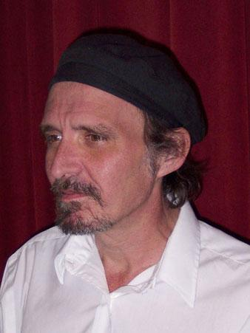
Fredericksburg, Texas for the last thirty years where he teaches piano, composes and directs the Fredericksburg Chorale and two German choirs. He has a Bachelor's Degree from the University of Texas at San Antonio in piano performance and a Master's Degree from the Eastman School of Music in piano performance and literature.

Many of his compositions have been published by Boosey and Hawkes, Colla Voce and Alliance Music Publishers. His works have been performed all over the United States and Europe. Two of his choral works have been performed at Carnegie Hall. His compositions and improvisations have been featured on a number of occasions on Texas Public Radio.

